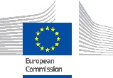
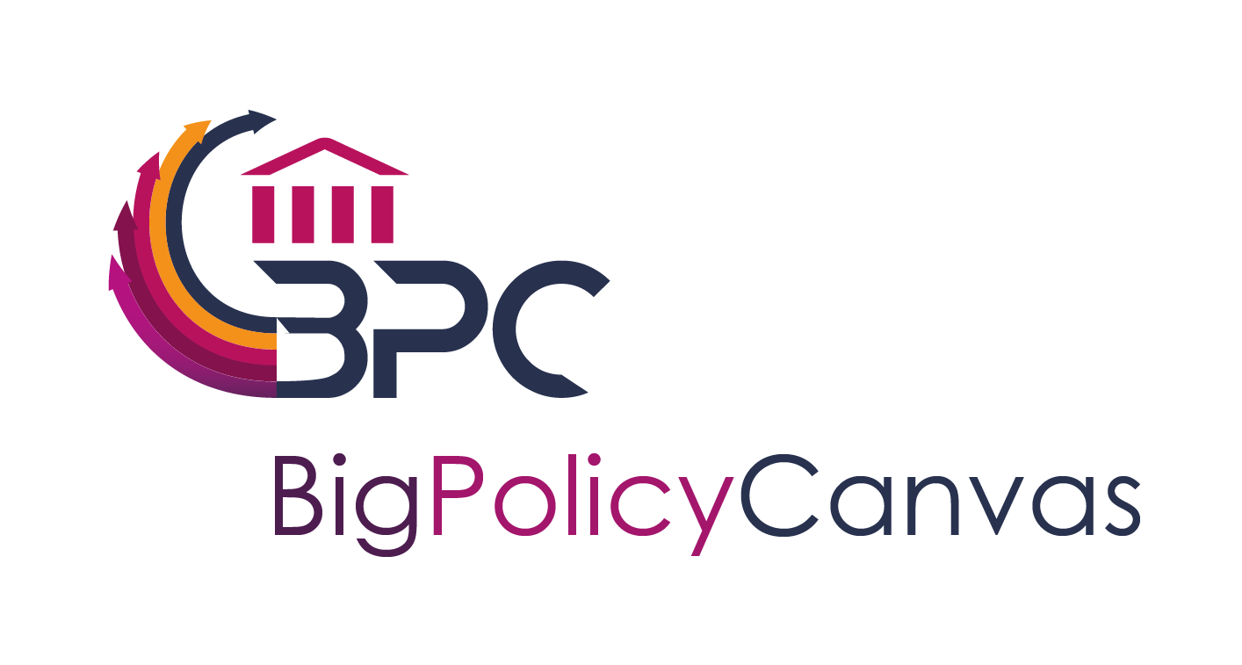

Big Policy Canvas Final Event in “Major Cities of Europe” Conference
Date

BPC, building a more effective, efficient, precise and (big)data-based public sector

Nowadays, the current socio-economic conditions call for a radical shift to a new mentality of efficient utilisation, co-creation and cost-effective public services. New concepts, that consider the available (big)data and ensure accurate and meaningful input to public sector organisations, are of the utmost importance in order to support and establish new types of informed-based policy making. However, although the aforementioned needs are in general unanimously identified by all public sector stakeholders, there are numerous issues that have to be tackled towards streamlining the process of reshaping and innovating public sector:
- How to identify, monitor, early detect and assess public administrations’ needs?
- How to timely get aware of emerging methodologies, tools, technologies and applications that can respond to these needs?
- How to effectively identify external framework factors that affect public sector activities?
Big Policy Canvas project is celebrating its final event sharing with all interested stakeholders its view on these questions and presenting the BPC Roadmap with future research directions and specific recommendations related to the use of big data in policy making.

Final Event Walkthrough
The event will start with a presentation of the project’s results and their contextualisation in the evidence-based policy making area. After that, a highly-interactive session will follow with the BPC Roadmap for future research directions and recommendations playing the greatest part in the discussions. It is expected that representatives of public authorities, civil society organisations, ICT research organisations, big data providers and companies will participate and contribute.
The BPC final event will be held on Friday June 14th, 11:00 CEST in the Major Cities of Europe Conference, in Venice (Italy). Attendants to our workshop will enjoy a special conference price.
Contact us in: https://www.bigpolicycanvas.eu/contact
Join us and be part of the future!

